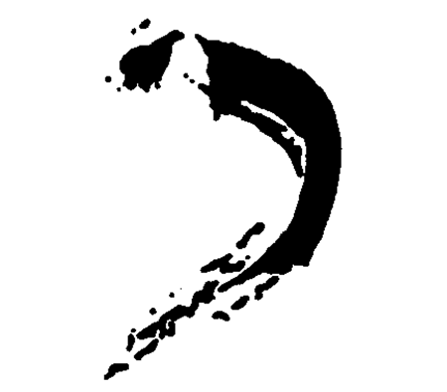
KHAKI GALLERY
9 Crest Road, Wellesley, MA 02482
781-237-1095, www.khakigallery.net

For immediate release:
October 2007

“Education of Ruby Hazzard”
Ruby Hazzard
October 8 – November 10, Reception: October 12 , 6-8

Khaki Gallery is pleased to present “Education of Ruby Hazzard” by the emerging fine art photographer known by her pseudonym Ruby Hazzard.
The photographs featured in this exhibition are self-portraits in the style
of yearbook photographs. As both a performer and a photographer, Hazzard is entirely in control of her final images. Many photographs show her characters in a serious introspective mood while in others she is either
mischievous or nostalgic for bygone eras.

Ruby Hazzard graduated from the New England School of Photography in 2003, majoring in Fine Art Color Photography. She has continued working
at the school, initially as a teaching assistant and currently as a facilities staff supervisor. Ruby Hazzard grew up in the Fargo-Moorhead area on the border of North Dakota and Minnesota. In high school she worked for a portrait photographer who specialized in senior portraits, which later influenced her to begin her longtime project in yearbook-style photographs. The yearbook style of photographs came about serendipitously. As the artist explains: “After having difficulty getting models to sit for my images, I began to make pictures of myself. By tossing on a wig, dressing in different clothes and applying make up, I was able to alter my appearance and be transformed into one of the many types of people who so interests me. Using a yearbook layout was an ideal way of showcasing my self-portraits…My images are predominantly about people and their behavior. More specifically, I am fascinated by their attitudes and their physical representations. Through studying other people I began to look at myself.

This introspection led to a series of images in which the subjects took on life of their own. My characters became visual representations of aspects of my own personality.”

Hazzard shot all her self-portraits using a Photogenic lighting setup with a soft box and reflector bowl and a remote shutter release for a Nikon N65 35mm camera on Kodak Ultra 400UC professional color film. All images were originally printed by the artist on 5x7 Kodak Supra Endura N Surface paper. Later, Hazzard scanned all the images and arranged them into grids with the use of Photoshop and then enlarged and printed them digitally on Kodak Supra paper.

