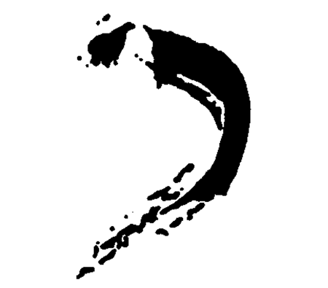
K H A K I G A L L E R Y
460 Harrison Ave. Boston, MA 02118, 617-423-0105
9 Crest Road, Wellesley, MA 02482, 781-237-1095
www.khakigallery.net , khaki@khakigallery.net

For immediate release:
February, 2009

JAMES PARADIS “Inside-Out Outside-In”
NAHID KHAKI “Beach Blues”
March 3 – April 11, Reception: March 6, 6-8

Khaki Gallery Boston is pleased to present “Inside Out – Outside In,” painted sculptural shaped canvases by James Paradis and “Beach Blues,” photographs by Nahid Khaki.

James Paradis has been exhibiting his works for several years in different group and national juried shows in and around Boston. In his late sixties, Paradis enrolled at the Mass College of Art, receiving a BFA in 2005. In 2003, Paradis exhibited his first solo show “Turbulence” at the French Library and Cultural Center of Boston. In the same year, he was in a two man show at the Iris and B. Gerald Cantor Gallery at the College of the Holy Cross in Worcester, Mass. He has exhibited in Auvillar, France where he was invited as an artist in residence of the Centre d’Exchange Cultural d’Auvillar in 2002 and 2003.

Paradis says about his work: “As a painter I am always taking risks to move to another plateau, going beyond myself. It allows me to create something which is a new “other”.
...This happens when I arrive at that point in my thinking and work when I feel I have given form to something that existed earlier only in my mind, in my being and is ready
to be released and transformed in the process. I am willing to risk this public transformation in to the “other”. It is that moment when the work becomes a reality, “flesh and blood” so to speak, an extension of me. My art is the product of those moments, the exploration of a fool playing with ideas and forms and being willing to risk being the “other” in that process.”
Nahid Khaki is an Iranian-born artist living in Massachusetts. She has been active as an artist and photographer for the past three decades. Since 2005, she has been the director of Khaki Gallery in Wellesley and most recently the Boston Khaki Gallery, where she has exhibited works by many emerging artists. “Beach Blues” is an ongoing collection of photographs that Khaki originally exhibited in 1999 in Karpeles Manuscript Museum in Santa Barbara, California. Khaki’s style in these photographs varies from monochromatic, minimalist and abstract nature photography to unique naturalism. As she says: “In my photography, I seek and achieve a certain level of peace, quietude, simplicity, Zen, and organization, despite the unrest in the world…Life is presented in a simple and understandable manner, unlike reality…These pictures are about seeing – seeing the unseen; seeing the ordinary seeing the extraordinary, seeing the invisible… These pictures are about following ones instincts and being spontaneous. They are about being insignificant, forgetting oneself, and being mindful of the moment…I am part of this vastness. I am nothing, and I am everything. I am the rock, I am the water, I am the sand, I am the dead seal, I am the wind..I am connected to this universe and at the same time I am separate. I am part of everything and I am part of nothing… I become an observer, I become a witness...There is no words that can explain what I see. I can only document what I see as best as I can, without interference. I use my camera as a tool to paint, except the painting has already been created outside of me. I find pieces of this amazing painting with the aid of my camera. I find miracles everywhere….”

