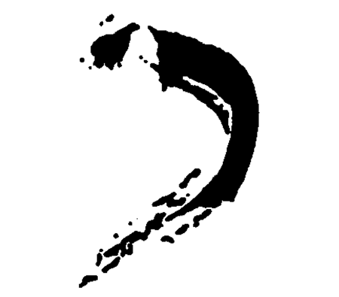
KHAKI GALLERY
9 Crest Road, Wellesley, MA 02482
781-237-1095, www.khakigallery.net

For immediate release:
August 2007

“Phases of the Moon and Other Lessons in Science”
KEVIN VAN AELST
September 1 – October 6, Reception: September 7 , 6-8

Khaki Gallery is pleased to present “Phases of the Moon and Other Lessons in Science” by Connecticut- based photographer Kevin Van Aelst. As the
title suggests, the images displayed in this exhibition are pictorial representations of some of the most common subjects in science, namely,
fractal geometry, chaos theory, biology and chemistry. In his conceptual and minimal approach, Van Aelst creates a colorful, playful and humorous world where with the use of common everyday objects and foods, he
illustrates timeless and lofty ideas.

Kevin Van Aelst attended Cornell University where he received a degree in psychology. Van Aelst moved to Connecticut in 2003 and received a MFA from the University of Hartford in 2005. His work is in permanent collection of the Wadsworth Atheneum Museum. Van Aelst has already been hailed as “an up and coming photographer” by the New York Times on the strength of his “Complex Confections” exhibition in 2005 at Real Art
Ways in Connecticut. He currently teaches photography at the Quinnipiac
University.

As Van Aelst explains: “Subjects of my color photographs include every day foods and objects: bread, doughnuts, crackers, candy, floor tile, sweaters, and lint. These simple materials are arranged into shapes and patterns inspired by formulas found in science and mathematics, such as fractal geometry, chaos theory, biology and chemistry. The palette is informed by the colors of these mundane objects, so that colorful frosting finds its shape as the organelles of a dividing cell, or that bright gummy worms become the chromosomes on a chart of the human genome…This body of work is about creating order where randomness is expected, defying natural probabilities, so that lint stuck to a sweater forms an accurate star chart of the summer
sky over New England, and milk spills from its carton into a logarithmic
spiral. While the subjects of the photos are artifacts of modern culture,
the content of the photos, such as the Golden Mean, are often ancient and
revered notions.”

Van Aelst’s images were shot mostly with a Large format Cambo monorail studio view camera on Fujichrome 4x5 film and printed on Fuji Crystal Archive paper. The largest of these prints were made by scanning sheets of film and creating digital light jet prints. Even within those pieces printed digitally, all arrangements and manipulations of objects were all done entirely by hand. While this work is sculptural by its material nature, Van
Aelst photographs the result so that the scale can be changed, or so that fleeting and temporary configurations (such as of milk in coffee or debris on a floor) can be frozen in time and made permanent.

