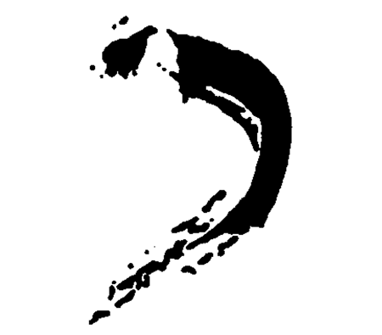
K H A K I G A L L E R Y
460 Harrison Ave. Boston, MA 02118, 617-423-0105
9 Crest Road, Wellesley, MA 02482, 781-237-1095
www.khakigallery.net , khaki@khakigallery.net

For immediate release:
January, 2014
“Convergence Part I”
Jan 3 – Feb 14, Receptions: Jan 3 & Feb 7: 6-8

Khaki Gallery Boston is pleased to present “Convergence Part I,” first of the two group exhibitions by students from School of the Museum of Fine Arts. Artists featured in this exhibition are: Allison Cekala, Crystal Cudworth, Khaldoun Hijazin, Tiara Jenkins, Soo Young Kim, Greg Lookerse, Ryan McMahon, Helina Metaferia, Nickolas Procopi, Eric Stefanski, Gianna Stewart, and Eryn True.

“Convergence” is not based on any themes but rather is curated for a harmonious visual aesthetic as a whole, while engaging in a dialogue among individual works of art. The works featured are from a wide range of mediums, including color and black and white photography, painting, collage, sculpture, video and performance.

The diverse styles of art featured in this exhibition range from social satire in the form of surrealistic style painting “Shoeman,” by Khaldoun Hijazin, a Jordanian artist, who uses symbols and signs in order to construct narratives that embody social injustice, “to me the illusion of a realistic space is my way to invite the viewer to enter my picture plane and touch the illogical fragments I introduce…” Hijazin said; to impressionistic style, lightly painted monochromatic oil paintings by Crystal Cudworth who captures light through glazing techniques. Cudworth says: “Based on collages and watercolor studies, the oil paintings begin from observations of natural light and continue the dialogue with impressions in nature and further mediation…” On the other hand, Eric Stefanski uses fashion magazines, spray paint, faux flowers and plastic as signifiers for vanitas themes in his assemblages to explore the contemporary culture within the context of 16th and 17th century Dutch still life painting. “My pallet wall sculptures combine repurposed structures and the discourse of contemporary abstraction…” Stefanski said.

In the genre of landscape photography, Allison Cekala’s large grid of 12 black and white photographs “Untitled (Construction Sites Boston),” is the result of explorations in her neighborhood in which Cekala discovered sublime landscapes within ubiquitous, temporary forms made from construction debris. As she says: “These mountains are construction sites. These construction sites are mountains.” Ryan McMahon’s self-portrait photographs explore ideas about female identity at different stages of life, “Looking at the cultural constructs of marriage and ideas about family, raising children, building communities, cities and creating connection while also looking at mental illness, behavioral analysis psychology and trauma studies and how isolation, depression and anxiety can come out of technology’s purpose to connect.” McMahon said.

South Korean artist, Soo Young Kim grew up in both Eastern and Western world, and experienced the merging into two very different cultures from a young age. Her works deal with issues of “home” and transforming, migrating, and merging of identities. In “Inosulation (Conjugation),” two identical figures made of metal mesh and paper fiber are merging into one another. “ Through my sculpture, I cease to be an island of my own, and strive to create pieces that seek out to other human ‘islands,’” Soo Young Kim said. Interdisciplinary artist Helina Metaferia, a first generation Ethiopian-American, also works with themes of identity, globalization, and interconnectivity. As she says “By actively engaging with the audience in video performance work, I seek to overcome the limitations of time, space and technology by making the images participatory…”

Eryn True explores the idea of the home and our relationship with the natural world throughout her sculptural work. “Balancing Bricks,” focuses on the balance between nature and the man-made world we have imposed upon it. As True says “My work attempts to alter one’s assumed perception to give light to new possibilities of viewing the world around us.” In her videos, Gianna Stewart also deals with ideas about home and building one. For forty years Gianna’s grandfather has been building his current home. “There is a place in constant flux with transient walls….A mess, a cacophony of materials scattered about, a home that will never be clean, never sterile. Constantly transforming nooks collide into one another. Ad hoc compositions meld with the soothing backdrop of the lake. This steady, consistent landscape is framed by ever-changing materials and layers of structure as shifting as a pile of birdseed beneath a hungry group of chickadees,” Stewart said.

The videographer, installation artist and performer Greg Lookerse is originally from Los Angeles. His work draws upon influences from both coasts. In his current work, Lookerse is interested in incongruities between physical objects and their use as metaphysical symbols. His performance include sculptural objects made from carefully selected materials so that they may act as tools to help investigate these incongruities. As Lookerse says, “Both of these videos explore the use of material as a stand in for some sort of religious symbolism.” Performance artist Tiara Jenkins explores issues of loss separation and becoming in her 20-minute performance titled “Burden, Hold, Drop, Release.” Nick Procopi who creates work in photography, performance, video, and sound will also perform a piece titled “Vestment.”

