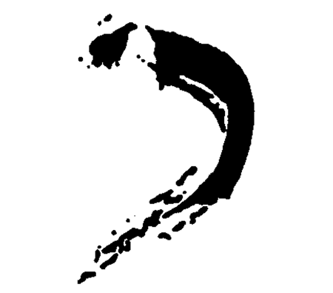
K H A K I G A L L E R Y
460 Harrison Ave. Boston, MA 02118, 617-423-0105
9 Crest Road, Wellesley, MA 02482, 781-572-7263
www.khakigallery.net , khaki@khakigallery.net

For immediate release:
April, 2017
N A H I D K H A K I
“American Dream”
April 7 – May 30, 2017
Opening: April 7, 6-8

Khaki Gallery Boston is pleased to present “American Dream,” new paintings and sculptural installations by Nahid Khaki. This exhibition continues her exploration of the themes of politics, materialism, immigrants, refugees and feminine identity. Khaki’s new paintings are satirical portraits of current political characters and her sculptural formations are created using personal domestic detritus, fabric and recycled materials.

“American Dream,” the title piece of this exhibition, is a sarcastic sculptural painting of a contorted human figure made of fabric, yarn, mesh wire and rope on canvas in the colors of the American flag, white, red and blue. “Refugees’ Piles,” is a sculptural formation hinting at a human figure with his/her life’s colorful belongings wrapped with black fabric in piles. “Blue Medusa,” is another sculptural painting on canvas in the shape of a feminine blue dress with her neck broken and her head hanging with blue ribbons coming from all directions like the head of Medusa, referencing misogyny and a female’s plight in our world. “I did these works in the summer of 2015 after two rough years of being in graduate school and getting my MFA and facing the reality of my life as an immigrant, middle-aged female artist in this country with a grim outlook. My feelings at the time were a foretelling of worse yet to come. The current state of our government and country is anything but hostile to people like me - who came here 42 years ago with an American dream, a hope and an ideology shared by so many people from all over the world who want to make the best of their lives in this greatest country on earth.” Khaki explained. In the installation titled the “Wall crossing,” several humanoid legs made of soft fabric, yarn and string are hanging from the top of a long mirrored-wall in the gallery. These figures invoke the idea of immigrants crossing a long and shiny American wall as talked about in our current political atmosphere. Also featured in this exhibition are ten satirical portrait paintings of current political characters which are from an ongoing series titled “The Shithead Lies.”

“My work explores the dichotomy between a personal narrative and a social commentary,” Khaki explained. “By selecting and appropriating everyday objects and materials from my own life, I transform these disposable surplus items into completely new forms with different narratives while still bearing traces and evidence of their human presence. The work is driven by personal life experiences and political and social circumstances that effect the human conditions (wars, refugees, women’s inequality, racism, income disparities and so on) and it is comprised of complementary, contrasting and opposing hybrid elements which grow out of tension between past and present, memory and fantasy, freedom and repression, celebration of life and lament, chaos and order and familiarity and otherness. To offset the grimmer aspects of life in general - in particular the socio-cultural baggage of an immigrant’s life - my work is often leavened with humor and absurdity.”

Nahid Khaki is an Iranian-born artist who has been active as an artist for the past three decades while living in the USA since mid 1970s. Khaki has been has been the director of Khaki Gallery in Wellesley since 2005 and in Boston since 2008 and has exhibited works by many emerging artists. Khaki obtained her MFA from the School of the Museum of Fine Arts in Boston/Tufts University in May 2015. She also received a BA, BFA and MA from UT Austin 1982-1988.

